Sample text: Font Arial 12
970 Madison Oak Park Illinois 60302 ph: 708.524.3000 fax: 708.524.3019 www.op97.org

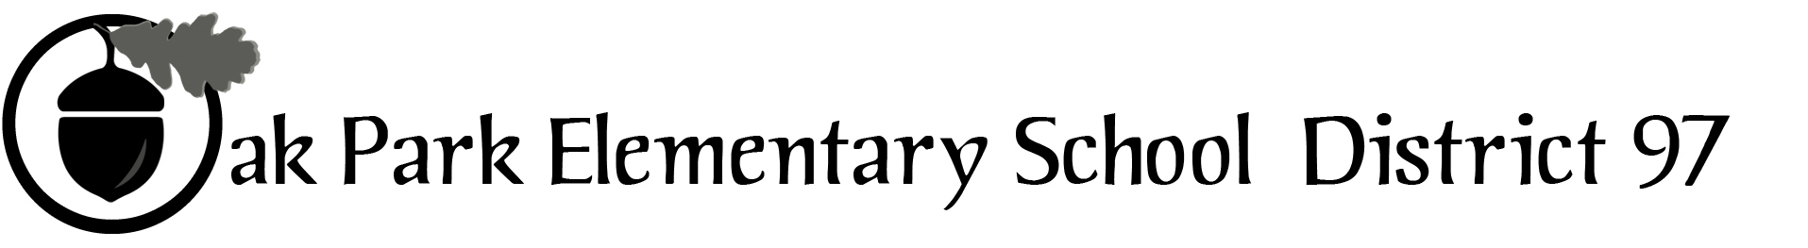

District 97 board member Liaison Report
This report was created and submitted by board members who serve as liaisons to board committees, administrative committees or community organizations. It is a brief summary of the committee or organization’s most recent meeting. It does not serve as or represent official minutes of that meeting.

Name of the committee/organization: Oak Park Education Foundation board

Date of the meeting: September 21, 2016 (see attached agenda)

Names of the District 97 board liaisons: Rupa Datta

Names of the District 97 administrative representatives (if applicable): Helen Su, John McCauley (Holmes)

Brief summary/key outcomes of the meeting: Summer 2016 was very successful.

Deb Abrahamson, Executive Director, announced her resignation effective the end of the calendar year. A search committee will be convened, possibly including appointment of an interim director.

Discussion Topics: Plan for conducting a search for a new Executive Director.

Next steps: None.

Questions/feedback for the District 97 board: Please let Rupa know if you have input on the Exec Dir search, she can share information about the search committee chair as available.

Date of the next meeting: October 19, 2016. October 27, 2016: Legopalooza at Fitzgerald’s

Supplemental documentation (e.g., agenda, reports, etc.) from the meeting (attached): Materials attached.

Report submitted by (include name and date): Rupa Datta, September 29, 2016

