Sample text: Font Arial 12
970 Madison Oak Park Illinois 60302 ph: 708.524.3000 fax: 708.524.3019 www.op97.org

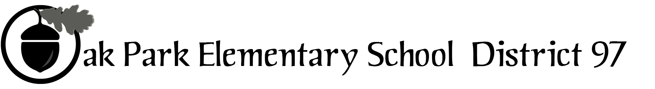

District 97 board member Liaison Report
This report was created and submitted by board members who serve as liaisons to board committees, administrative committees or community organizations. It is a brief summary of the committee or organization’s most recent meeting. It does not serve as or represent official minutes of that meeting.
Name of the committee/organization: FAC
Date of the meeting: November 14, 2016
Names of the District 97 board liaisons: Holly Spurlock
Names of the District 97 administrative representatives (if applicable): Dr. Alicia Evans
Brief summary/key outcomes of the meeting: The agenda consisted mostly of the administration reporting updates to the FAC. We also introduced 2 new members, Heather Guido who is an Architect and Darryl Baker who is a project manager with expertise in temperature controls. Both are parents of Hatch students.
Dr. Evans reported on the temperature control report and the costs associated with acquiring some of the data obtained through the individual thermostat units. We determined that having the information would be critical to FAC in the event that the Board requested a definitive recommendation about moving forward with the temperature control plans that are contained in the 10 year facilities plan. A brief discussion was had about the administration’s process for referring building improvement donations to the FAC if a recommendation was desired. We also reviewed the most recent inspection results and the admin building reconciliation.
Dr. Evans and I updated the committee on the Village’s position with regard to Hatch/Holmes. We thanked them again for their work on the review and recommendation and informed them of the current status of conversations with the village. They were able to understand our frustration with the process and are standing by to offer additional support as needed.
In addition to these items that were reported on, a parent from Irving attended the meeting to listen to the FAC recommendation about the turf field. The committee discussed it and ultimately concluded that the issues at hand, i.e. EPA issues related to the health and safety of the rubber crumble, were beyond their expertise and declined to make a specific recommendation. I explained to the parent the next steps in the process.
Next steps: N/A
Questions/feedback for the District 97 board: We have a quote for ~$61K for replacing the filler that was attached to Dr. Kelley’s weekly report and may be presented for consideration.
Date of the next meeting: N/A
Supplemental documentation (e.g., agenda, reports, etc.) from the meeting (attached): Turf docs
Report submitted by (include name and date): Holly Spurlock, November 15, 2016

