Sample text: Font Arial 12
260 Madison Oak Park Illinois 60302 ph: 708.524.3000 fax: 708.524.3019 www.op97.org

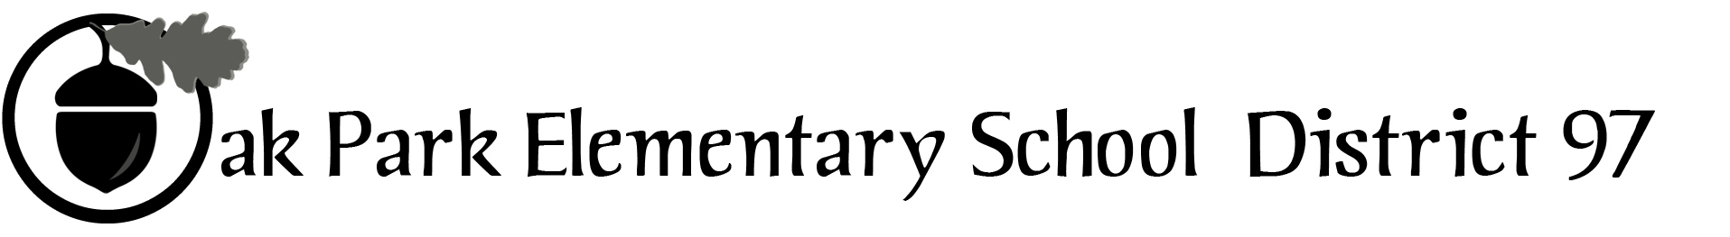

District 97 board member Liaison Report
This report was created and submitted by board members who serve as liaisons to board committees, administrative committees or community organizations. It is a brief summary of the committee or organization’s most recent meeting. It does not serve as or represent official minutes of that meeting.
Name of the committee/organization: COG
Date of the meeting: June7, 2017
Names of the District 97 board liaisons: Holly Spurlock
Names of the District 97 administrative representatives (if applicable): Dr. Carol Kelley
Brief summary/key outcomes of the meeting: Each taxing body updated the group as follows below and an overall discussion of collaboration:
- Park District:
  - Camp and summer school
  - Presentation and agreement with D200 re: Community Center
  - Passport program
- Library:
  - Elimination of fines
  - Partnership with D97 re: library cards
- D200:
  - New Facilities plan
  - Transgender policies development
- D97:
  - Equity Policy development and staffing
  - GTD, Library Assistants and Bravo/Cast update
  - Commercial dev as a referenda theme
- Village
  - Commercial Dev
  - Mentoring initiative

Next steps: Discuss with individual Boards how we want to handle projects being led by other taxing bodies, presentations, and providing information.
Questions/feedback for the District 97 board: How should we positively fulfill our commitment to commercial development coming out of the referenda?
Date of the next meeting: August
Supplemental documentation (e.g., agenda, reports, etc.) from the meeting (attached):
Report submitted by (include name and date): Holly Spurlock, June 13, 2017

