Sample text: Font Arial 12
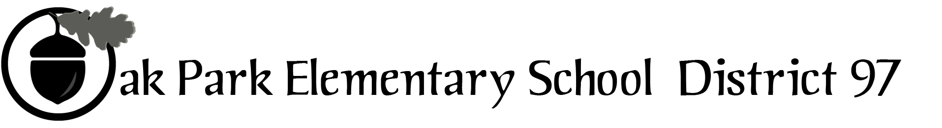
970 Madison Oak Park Illinois 60302 ph: 708.524.3000 fax: 708.524.3019 www.op97.org

District 97 board member Liaison Report
This report was created and submitted by board members who serve as liaisons to board committees, administrative committees or community organizations. It is a brief summary of the committee or organization’s most recent meeting. It does not serve as or represent official minutes of that meeting.

Name of the committee/organization: IGOV (Intergovernmental Committee)

Date of the meeting: April 22, 2017

Names of the District 97 board liaisons: Jim Gates and Holly Spurlock

Names of the District 97 administrative representatives (if applicable): None assigned

Brief summary/key outcomes of the meeting:
- Opening discussion led to a decision to postpone the planned May 20, 2017 IGOV assembly
- The remainder of the discussion resulted:
- An an IGOV member postmortem of the past 2 years to be shared by IGOV members with their taxing body current Board member and newly elected members. (Please note: note this was accomplished by J. Gates and S. Marinier on 4/26/17)
- Around the Table Updates (See P. 3)

Next steps:
- IGOV members Sara Spivy, Paul Aeschleman, Clarmarie Keenan, Sara Spivy, and IGOV Admin. Asst. Lou Anne Johannesson will work together to determine the next steps for IGOV.

Questions/feedback for the District 97 board:
- None
Date of the next meeting:
- TBD
Supplemental documentation (e.g., agenda, reports, etc.) from the meeting (attached):
- IGOV agenda ( P. 2)
- Around the Table (P.3)

Report submitted by (include name and date): Jim Gates and Holly Spurlock

IGOV: Intergovernmental Body of the Village of Oak Park

Saturday, April 22, 2017
9:00 AM Township Board Room
105 S. Oak Park Ave.

Meeting Plan

- Open
Present:
Absent:
- Review / revision of meeting plan:
- Review of previous meeting notes:
- Around the Table Sharing:
- Discussion topics
- Discussion and planning re: the 5/ 20/17 Assembly
- Looking to the future: IGOV continuity after recent elections
- Other items as necessary

- New business

- Next meeting

- Date:
- Proposed Meeting Plan Items:
- Member tasks to prepare for meeting:
- Close:

Around the Table Sharing

D97:
- Ethnic Festival Parade and activities start at Percy Julian at 10:00 and run until 3:00. (New Board members: it is a long-standing tradition that D97 Board members bring a large bag of candy to toss to spectators along the parade route. J. Gates)
- The Lion King at Brooks MS May 5-7 and 12-14
- Impressive list of ISBE Those Who Excel nominees can be found on D97 website
- Sale of 541 Madison was approved by the Board
- CCE (Committee for Community Engagement) has begun its work to enhance Board-community 2-way dialogue
- New Board to be seated on 4/26

Parks:
- Euclid Park renovation underway
- Maple Park is open and renovation is being enjoyed by the citizenry
- Cheney Mansion Children’s Art Show April 29

D200:
- April 27 Board meeting including vote on new discipline policy
- May 1 D90, 97, 200 Tri-Board meeting

Township:
- Search is on for new Senior Services director
- May 9 new Board will be seated
- Township Consolidation bill is in Illinois Senate
- Township has decided to purchase its own buses to provide Township service transportation flexibility in terms of hours, destinations outside of Oak Park and River Forest at a reduced cost as opposed to using an outside vendor.

Village:
- The village of Oak Park could impose a fee of 10 cents on all single-use plastic bags at retail stores, under a recommendation from the village's Environment and Energy Conservation Commission. The proposed ordinance will be further studied by village staff and return to the board for a vote in the coming weeks.
- The issue and discussion related to a Tri-Village sustainability coordinator has led to a concern that it is being said that as no other taxing bodies were willing to sign on, the Village had to step in and act. (I recommend that Bob Spatz, D97 Board liaison on this topic share his knowledge on the work of this issue. J. Gates)
Library:
- Plans for an engaging summer reading program for children have been developed

