Sample text: Font Arial 12
970 Madison Oak Park Illinois 60302 ph: 708.524.3000 fax: 708.524.3019 www.op97.org

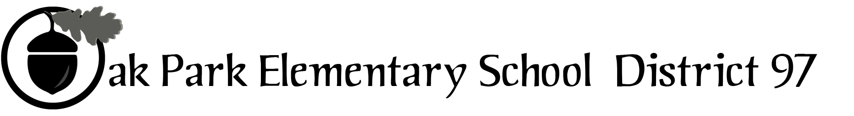

District 97 board member Liaison Report
This report was created and submitted by board members who serve as liaisons to board committees, administrative committees or community organizations. It is a brief summary of the committee or organization’s most recent meeting. It does not serve as or represent official minutes of that meeting.

Name of the committee/organization: OPRF Citizen’s Council

Date of the meeting: March 10, 2016

Names of the District 97 board liaisons: Graham Brisben

Names of the District 97 administrative representatives (if applicable): N/A

Brief summary/key outcomes of the meeting: The meeting opened with approval of the prior meeting’s minutes, followed by the Superintendent’s Report. Superintendent Isoye reported that
- The board was working to engage the community in mid April on the topic of the pool. They were seeking public input to help review potential options.
- The Long Term Facilities Committee would be meeting on Monday 3/14 to discuss options and ideas for space renovations.

Next was board member Spivey with the board report. She reported that there would be a special board meeting next week to discuss the topic of teacher stipends. This was being done in the context of budgeting and ensuring there would be sufficient staff to support different clubs and extracurricular activities.

The next topic was a presentation by staff member Chris Thieme on the 1:1 technology program that D200 is considering. The district is currently tackling all the issues typical with such a program such as staff training, loss prevention, potential fees, privacy, and appropriate use. The administration is developing a recommendation that will be presented to the board. Chris presented a brief slide show along with his verbal remarks (attached).

The next topic was an announcement that OPRF special education teachers were trying to develop improved transition (post graduation) services for D200 students, based on internal surveys indicating that this was an area of need. The focus is on building out a network of folks who can help with the post-D200 transitions. A community forum was planned on this topic for March 21. A document introducing the SPED Transition Divisional Collaboration Team was provided (attached).

Next we heard a presentation from Katie Madock and Lisa Makely of the student services division on social work, PSS team, and overall school climate and culture. It was reported that social workers were trying to hit 9th grade study halls to offer help of various kinds to freshmen students. There is also an effort to reach out to those kids getting in-school suspensions in different ways, touching on mindfulness, anger management, etc. (Interestingly, 80% of in-school suspensions are for the offense of failing to serve detentions that are themselves the result of tardies). The staff has also developed a wide range of student support groups (see attached list). About 75% of the listed groups are operational and meeting once per week with about 5-10 kids each.

Board Member Spivey and Dr. Isoye then spoke about the new committee on Culture, Climate, and Behavior (formerly known as PTAC). They said that a disciplinary code focused on prevention was being developed. The goal was to think about discipline holistically, as a social-emotional lesson – not strictly about punishment. Parents, teachers, school community members, and students will make up the committee, with board members present but as non-voting participants. The committee’s objective is a disciplinary code that reflects the school’s values and how [we] would want to see kids mature into adults.

Next steps: None.

Questions/feedback for the District 97 board: None.

Date of the next meeting: Thursday, April 14, 2016
Supplemental documentation (e.g., agenda, reports, etc.) from the meeting (attached):
- Accompanying presentation on 1-1 Technology Initiative 031016
- OPRF SPED Transition DCT Intro 031016
- List of OPRF Student Services Social Work Groups 2015-16

Report submitted by (include name and date): Graham Brisben, 040316

