Sample text: Font Arial 12
970 Madison Oak Park Illinois 60302 ph: 708.524.3000 fax: 708.524.3019 www.op97.org

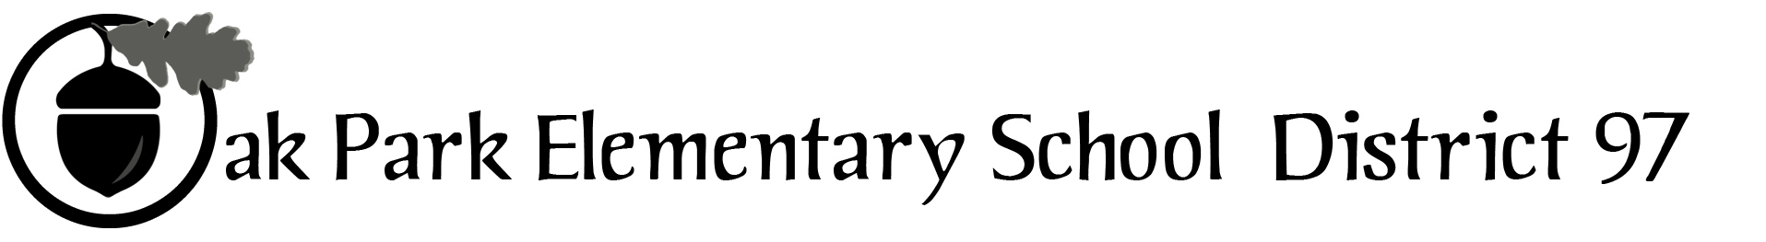

District 97 board member Liaison Report
This report was created and submitted by board members who serve as liaisons to board committees, administrative committees or community organizations. It is a brief summary of the committee or organization’s most recent meeting. It does not serve as or represent official minutes of that meeting.

Name of the committee/organization: CLAIM

Date of the meeting: October 15, 2015

Names of the District 97 board liaisons: Datta, Felton

Names of the District 97 administrative representatives (if applicable): Starks-Turner, Jasculca, Johannsen. (Kelley also present)

Brief summary/key outcomes of the meeting: The majority of the meeting time was spent on a presentation from ED-RED, with particular attention to the implications of state fiscal issues and actions on the district. The other major topic of discussion was planning for the November 2 legislators’ forum. One complication is the possibility of last-minute notice that the legislators will not be able to attend the forum due to being called in to session in Springfield. The committee has back-up plans in place.

Next steps: Please attend the Nov 2 forum!

Questions/feedback for the District 97 board: None.

Date of the next meeting: Nov 19, 2015
Supplemental documentation (e.g., agenda, reports, etc.) from the meeting (attached): Agenda attached.

Report submitted by (include name and date): Rupa Datta, 10/26/15

