Sample text: Font Arial 12
970 Madison Oak Park Illinois 60302 ph: 708.524.3000 fax: 708.524.3019 www.op97.org

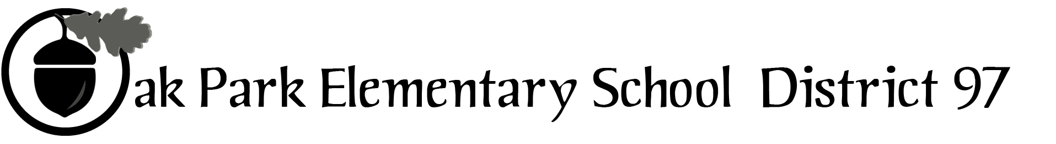

District 97 board member Liaison Report
This report was created and submitted by board members who serve as liaisons to board committees, administrative committees or community organizations. It is a brief summary of the committee or organization’s most recent meeting. It does not serve as or represent official minutes of that meeting.

Name of the committee/organization: Citizens Council

Date of the meeting: December 8, 2016 (see attached agenda and meeting minutes)

Names of the District 97 board liaisons: Amy Felton and Graham Brisbane

Names of the District 97 administrative representatives (if applicable): None.

Brief summary/key outcomes of the meeting:

Discussion Topics: Interim Superintendent Dr. Pruitt will being a listening tour in Spring 2017, in effort to update/develop a new strategic plan. Dr. Pruitt expressed concern that not all voices (students and parents) are being heard at the school. Parental involvement is different for different people and not all parents feel comfortable engaging with staff, teachers, etc.

A policy and procedure review related to sexual harassment is underway at OPRF. Staff has engaged in PD on the subject and students have been advocating for a more active leadership role in the context of sexual harassment focusing education on consent and on the message that no means no. Principal Rouse discussed that OPRF has been exploring de-tracking (as done at Evanston High School) and will continue to explore whether it might a fit for OPRF.

In an effort to increase in equity in opportunities/access, OPRF has identified 244 students in which the school will provide extra support (in the form of AP boot camps, summer bump ups targeted tutoring, etc.…)

Next steps: January 2017 meeting will focus on equity including efforts to increase access to and enrollment in AP classes.

Questions/feedback for the District 97 board: None.

Date of the next meeting: January 8, 2017, and February 9, 2017

Supplemental documentation (e.g., agenda, reports, etc.) from the meeting (attached): December 2016 Meeting Agenda and December Meeting Minutes are attached.

Report submitted by (include name and date): Amy Felton, January 14, 2017

