Sample text: Font Arial 12
970 Madison Oak Park Illinois 60302 ph: 708.524.3000 fax: 708.524.3019 www.op97.org

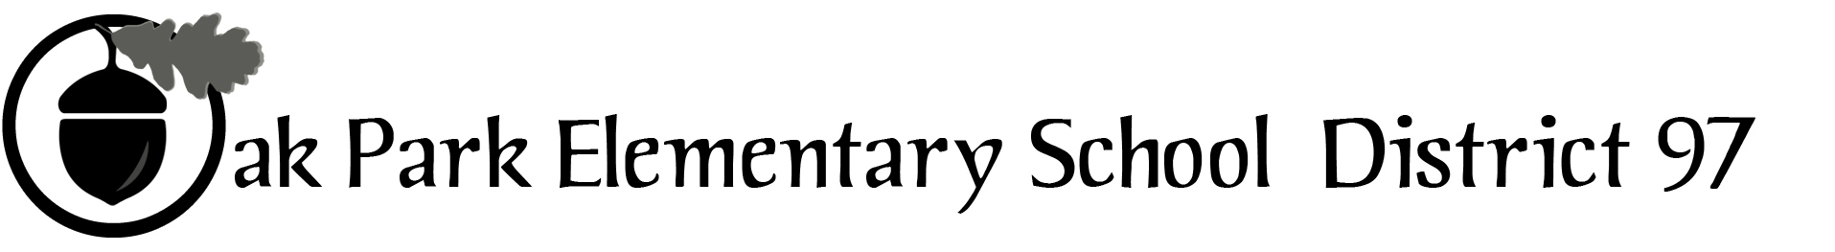

District 97 board member Liaison Report
This report was created and submitted by board members who serve as liaisons to board committees, administrative committees or community organizations. It is a brief summary of the committee or organization’s most recent meeting. It does not serve as or represent official minutes of that meeting.

Name of the committee/organization: FAC (Facilities Advisory Committee)

Date of the meeting: 3/7/17

Names of the District 97 board liaisons: Jim Gates and Holly Spurlock (attending other D97 event)

Names of the District 97 administrative representatives (if applicable): Dr. Evans and Lou Anne Johannessen

Brief summary/key outcomes of the meeting:
- Dr. Evans communicated to FAC:
- Board approval of Summer Bid packets, Village gave consent for the Holmes soil borings
- Need for 2 additional mobile classrooms at Holmes using DSEB dollars school 2017-18 school year; mobile classrooms need to be 30’ from building, permitted by the Village, and connected to fire alarm. Costs will vary upon issues such as plumbing.
- Landscaping bids are due on March 31. Can D97 and Parks share resources in this area. FAC suggested performance metrics / specs and related notices and penalties be part of landscaping contracts.
- Custodial supplies bids are due on March 15 on a per item bid basis.
- Referenda Updates
- Board information campaign is ongoing. Presentations and continuous updating of website information.
- Warehouse is for sale and District is working with the Village to review the move to the Public Works building and looking for bids by 3/14.

Next steps: TBD

Questions/feedback for the District 97 board: None

Date of the next meeting: TBD
Supplemental documentation (e.g., agenda, reports, etc.) from the meeting (attached):
- FAC Agenda 3/7/17 P. 2

Report submitted by (include name and date): Jim Gates and Holly Spurlock, 3/9/17

Facilities Committee Meeting
March 7, 2017
The Facilities Committee of the Board of Education of District 97 will meet in the Boardroom at 970
Madison Street from 7:00 p.m. until 9:00 p.m.

Agenda

I. Public comments (5 minutes)

II. Standing: Approval of Minutes/Review of Action Items (5 minutes)

III. Summer 2017 Bid Packets Approved/STR Updates (5 min.)

IV. Holmes School Updates (15 min.)
• Village
• Mobile Classrooms

V. Upcoming Contracts (5 min.)
• Landscaping
• Custodial Supplies

VI. Referendum Updates (15 min.)
VII. Adjourn

