Sample text: Font Arial 12
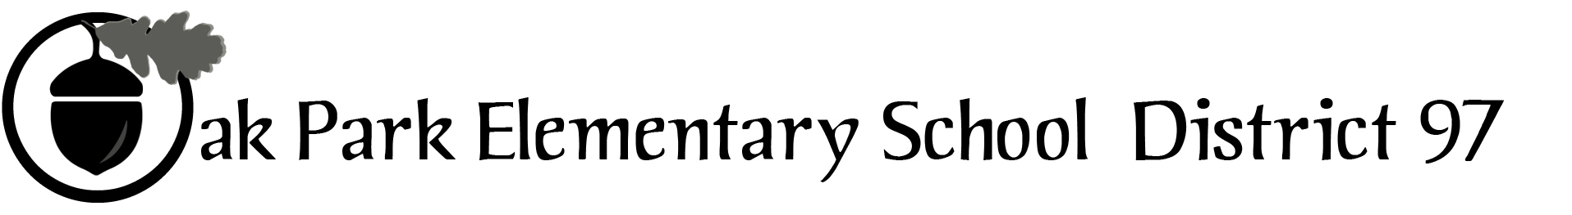

970 Madison Oak Park Illinois 60302 ph: 708.524.3000 fax: 708.524.3019 www.op97.org

District 97 board member Liaison Report
This report was created and submitted by board members who serve as liaisons to board committees, administrative committees or community organizations. It is a brief summary of the committee or organization’s most recent meeting. It does not serve as or represent official minutes of that meeting.

Name of the committee/organization: Community Engagement Core Planning Team (CPT)

Date of the meeting: 05/04/16

Names of the District 97 board liaisons: Rupa Datta and Jim O’Connor

Names of the District 97 administrative representatives (if applicable): Chris Jasculca and Superintendent Carol Kelley

Brief summary/key outcomes of the meeting:
- We will receive a report about the Community Conversations next week and this report eventually reported to the board at a June board meeting.
- Reviewed attendance and demographic make-up of attendance at Community Conversations. May not have heard from ‘disconnected’ parents.
- We discussed the attendees from the event and the topics that people brought up.
  - We also talked about how to message ‘what we heard’ so that it is comprehensive of what was shared and ‘the next step’ for the perceptions that were gathered.
  - We also discussed what would happen after the M2’s report and presentation to the board to make the most of the report and also take in other important data points and perspectives.
  - We also talked through the plan for the Superintendent’s Advisory Panel meeting on Wednesday, 5/10, so that we can move the conversation forward.

Agenda
- General update on the community conversations
- High level themes from the community conversations
- Style and substance of the community conversations report
  - We need to prepare the report to present to the Supt Advisory Panel next week (5/11)
  - We previously shared the report we did for D65 - http://www.district65.net/cms/lib8/IL01906289/Centricity/Domain/411/d65%20comm%20feedback%20presentation%20final%2012%2015%2014.pdf - is this a good model in terms of types/level of info, structure etc. or did you have something else in mind?

